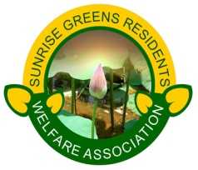
SUNRISE GREENS RESIDENTS WELFARE ASSOCIATION
12-A Ahinsa Khand, Indirapuram, Ghaziabad 201014.
Dear Residents
As JIDPL has written about parking allotment, we would like to inform you we have asked for more clarifications from JIDPL on parking allotment.
- JIDPL has details of every apartment; let them share details of IFMS first and Total Parking sold. Several residents have approached us that they find it difficult to find out receipts.
- It should be allotted as per GDA plan and declaration given by JIDPL.
- Allotment area should be 5.5 mt x 2.5 mtrs as per building norms and as per given declaration to GDA. Proper markings should be done.
- 10% additional space should be for visitors
- Parking area should have barriers which will prevent cars to take the area of other car.
- CCTV cameras to be installed as per promise of JIDPL.
- Additional Car park is to be sold once already sold parking is allotted.
- IFMS details should be shared with SGRWA from JIDPL as per their records. SGRWA will verify with residents along with JIDPL. IFMS money is collected from residents by default hence there is no need for verification. Total area of 1612000 sq ft x app Rs.20/- per sq ft shall be transferred to SGRWA at the time of handover.
For more details, please contact SGRWA office.
Date: 20-09-14

TEAM SGRWA

