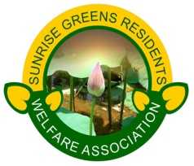
6th ANNUAL GENERAL MEETING
IN CENTRAL PARK
ON 5th OCTOBER’14, SUNDAY
STARTING AT10.00 A.M.
Dear Residents,
We sincerely “THANK” all residents for your continued support to the Executive Body during last two years. We have the honour to invite all residents of Sunrise Greens Residents Welfare Association for an Annual General Meeting to discuss and share our thoughts on following agendas’ in the meeting:
- Annual Report.
- Annual Account Report.
- Future Plans.
- Announcing the Elections as per UP Apartment Act’2010.
- Any other issue to be raised with due permission to Chair.
After the updates there will be question and answer session. We can have follow up session for debates on other issues if suggested in coming weeks if needed. Snacks will be provided. Tenants will not be allowed to participate in debates or question-answer session.
We request all residents to please update your ownership/tenancy records and pay your dues so that your name is reflected in voter’s list.
WE REQUEST ALL RESIDENTS TO RAISE THEIR WORDS, NOT VOICE.
IT IS RAIN THAT GROWS FLOWERS, NOT THUNDER!
Get ready to live your dreams. Sunrise Greens Society is fast shaping up.
PLEASE DO NOT MISS THIS A.G.M. AND GET INVOLVED!
Thanking you.

Manoj Pant, Gen. Sec, SGRWA September 20, 2014

